原稿フォーマット

英文誌●巻●号 原稿

執筆規程を必ず確認して下さい．
投稿時には説明や記載例等を消してご使用下さい．
著者情報は記載しないでください．

＜原稿の分量について＞
フォーマットを使用した場合、
投稿時の枚数入力で下記のように計算されます（少数第1位まで、2位以下は切り上げ）。
2割の超過でシステムがロックされて投稿できません。

要約(0.5 枚固定) + 本文(本文、文献を合わせた枚数の 3 分の 1) + 図表総量

(1) 投稿原稿の区分（いずれか１つを選択）

総説（Review article）
論説（Essay）
原著（Original paper）
短報（Short report）
資料（Material）

教育・実践研究（Educational and practical research）
症例報告／事例報告(Case report)

(2) 表題
冠詞と前置詞を除き頭文字は大文字で始める．
副題はコロンでつなぐ．コロンの直後（副題の冒頭）は語頭を大文字とする．
＜記載例＞Influence of Inward Pressure Applied by the Transducer during B-mode Muscle Ultrasound: Investigation of Several Trunk Muscle Thickness

(3) ランニングタイトル（12語以内かつ50文字以内）
＜記載例＞Influence of Inward Pressure on Trunk Muscles

(4) Key words （英語で5つ以内，固有名詞や略語以外は小文字で始める）
＜記載例＞ultrasound imaging, transducer, muscle thickness, MRI, Romberg test

Abstract
The purpose of this study was to clarify the change in trunk muscle thickness induced by different inward pressures of the transducer during ultrasound imaging. Eleven healthy male volunteers participated in the study. The thickness of the right transversus abdominis (TrA), internal oblique (IO), external oblique (EO), and lumbar multifidus (LM) muscles were measured by ultrasound imaging in the following two conditions, with inward pressures of approximately 0.1 N and 2.0 N. The mean difference between the 0.1 N and 2.0 N conditions were less than the minimal detectable change (MDC) of the 0.1 N and 2.0 N conditions in the TrA and IO muscles. The mean difference between the 0.1 N and 2.0 N conditions were greater than the MDC of the 0.1 N and 2.0 N conditions in the EO and LM muscles. Sensitivity of pressure is different among the trunk muscles. Maintaining consistent inward pressure of the transducer is required to clarify the minimal changes of muscle thickness in EO and LM muscles, rather than TrA and IO.

1. Introduction
B-mode muscle ultrasound^{†1)} was・・・such as low back pain^{1,2)}. ・・・has focused on transverses abdominis (TrA) and lumbar multifidus muscles (LM), because dysfunction・・・linked to low back pain (LBP)³⁻⁶⁾. Recently, Ishida and Watanabe⁷⁾ showed that ・・・. Akbari et al.⁸⁾ found that ・・・.

2. Methods
2.1 Participants
Participants were recruited・・・.

2.2 Procedure
2.2.1 Position
For collecting ultrasound imaging of the lateral abdominal muscles, the subject was positioned in the side-lying position (Figure 1).
Figure 1

2.2.2 Measurements
B-mode with a 10 MHz transducer was・・・.

2.3 Statistical analysis
SPSS Statistics 22.0・・・.

3. Results
The intra-examiner reliabilities are listed in Table 1.
Table 1

4. Discussion

Notes
†1) B-mode muscle ultrasound is・・・.

References
1. ・・・
2. ・・・

※執筆規程をよくご確認のうえ、誤りのないように記載してください。

＜原則＞

著者名と題名の間は，スペース・コロン・スペース（いずれも半角）．
題名と出版情報の後ろはピリオド，他の区切りはコンマ（いずれも半角）．
副題はコロンでつなぐ．コロンの直後（副題の冒頭）は語頭を大文字とする．
論文の掲載誌名および図書の書名はイタリック体とする．

＜記載例＞

雑誌論文の場合（基本）
（※末尾の括弧内は、日本語の論文であり、かつ英文タイトルと英文アブストラクトがあることを示す）
1. Ogawa S : Affect occurring in relation to sympathy from the other: Differences resulting from attributions of an event and intimacy with the other. The Japanese Journal of Educational Psychology, 59, 267-277, 2011. (In Japanese with English abstract)

【特殊なケースについて、以下のように扱う】

印刷中（掲載は決定しているが未刊行）：雑誌名の後にその旨を記載
1. Ogawa S : Affect occurring in relation to sympathy from the other: Differences resulting from attributions of an event and intimacy with the other. The Japanese Journal of Educational Psychology, in press. (In Japanese with English abstract)

早期公開（冊子体が刊行される前にオンライン上で公開）：雑誌名の後にその旨を記載
1. Ogawa S : Affect occurring in relation to sympathy from the other: Differences resulting from attributions of an event and intimacy with the other. The Japanese Journal of Educational Psychology, Advance online publication. (In Japanese with English abstract)

オンライン公開のみ（冊子体なし）の雑誌論文でDOIが付与されている：末尾にDOIを記載
5. Kawai N, Miyata H, Nishimura R and Okanoya K : Shadows alter facial expressions of Noh Masks. PLoS ONE, 8, e71389, 2013, https://doi.org/10.1371/journal.pone.0071389.

著者が10名を超える（11名以上）：9名まで列記し、その後省略のうえ最後の著者を記載
6. Kawai N, Kudo E, Saito S, Sakurai K, Sugawara K, Takemura K, Kawasaki S, Egusa Y, Okada K, ...Negayama K : Assessing social support: The Social Support Questionnaire. Journal of Personality and Social Psychology, 44, 127-139, 1983.

図書（単著）の場合
（※末尾の括弧内は、日本語の図書であり、英語表記がなく、投稿者自身が英訳を作成していることを示す）
2. Yoshida K : Assistance for mothers, children, and their families: Psychiatry of pregnancy and childbirth. Kongo Shuppan, Tokyo, 2005. (In Japanese, translated by the author of this article)

図書（編著書）の場合
3. Weidner N and Buckalew VM : Sickle cell anemia, sickle cell trait, and polycythemic states. In Tisher CC and Brenner BM eds, Renal pathology, Vol.2, JB Lippincott, Philadelphia, 1417-1436, 1989.

インターネット上の情報の場合
（※末尾の括弧内は、投稿者がこの情報を実際に確認した年月日、その直前のコロン前の数字は、サイト上でこの情報が公表された年を示す）
4. Brooks D : Adjusting to hearing loss during high school: Preparing students for successful transition to postsecondary education or training. http://www.pepnet.org/sites/default/files/20Tipsheet%20-%20Adjusting%20to%20hearing%20loss%20during%20High%20School,%20Preparing%20Students%20for%20successful%20transition%20to%20postsecondary%20education%20or%20training.pdf, 2009. (March 15, 2015)

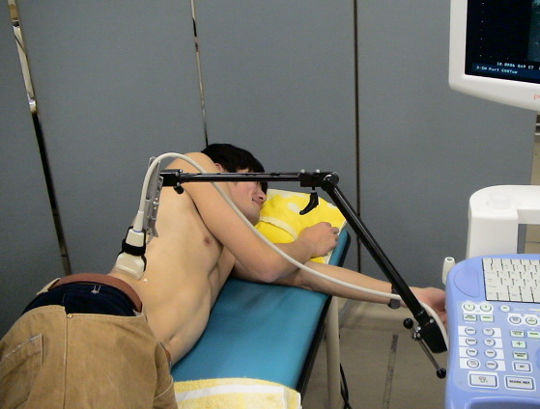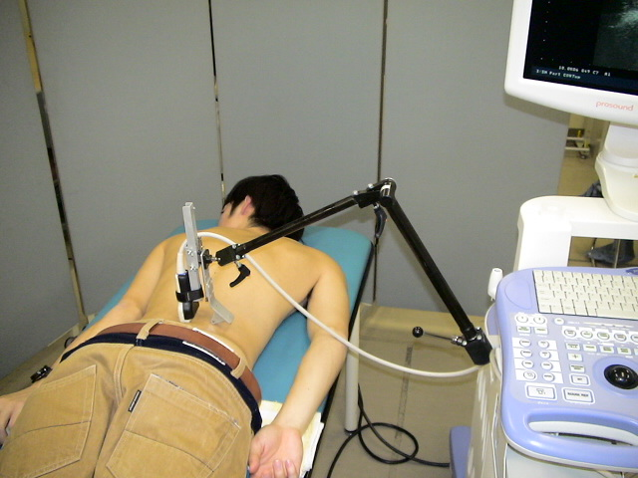
Figure 1 Measurements of ultrasound imaging for the lateral abdominal muscles (A) and the lumbar multifidus muscle (B)
A
B

Table 1 Intra-examiner reliability
 |  | ICC (1,3) | SEM (mm) | MDC (mm)
TrA | 0.1 N | 0.99 | 0.1 | 0.4
 | 2.0 N | 0.99 | 0.1 | 0.4
IO | 0.1 N | 0.99 | 0.4 | 1.2
 | 2.0 N | 0.99 | 0.4 | 1.2
EO | 0.1 N | 0.98 | 0.4 | 1.0
 | 2.0 N | 0.99 | 0.3 | 0.7
LM | 0.1 N | 0.99 | 0.4 | 1.1
 | 2.0 N | 0.99 | 0.4 | 1.1
ICC: intraclass correlation coefficients; SEM: standard error of measurement; MDC: minimal detectable change; TrA: transverse abdominis; IO: internal oblique; EO: external oblique; LM: lumbar multifidus.

Legends
＜論文に占める図表の総量：2分の1ページ＞

Figure 1 Measurements of ultrasound imaging for the lateral abdominal muscles (A) and the lumbar multifidus muscle (B) ＜大きさ：4分の1ページ＞
A
B

Table 1 Intra-examiner reliability ＜大きさ： 4分の1ページ＞
ICC: intraclass correlation coefficients; SEM: standard error of measurement; MDC: minimal detectable change; TrA: transverse abdominis; IO: internal oblique; EO: external oblique; LM: lumbar multifidus.

注）２行目の“図表の総量”は、個々の図表が刷り上がり（論文の印刷刊行）時に占めると著者が想定した分量をすべて加算したもの。上記の例では、Figure 1 とTable 1 がともに1/4ページのため、 1/4 ＋ 1/4 ＝ 1/2 （0.5ページ） となっている。

