Manuscript Format
Please read the Instructions for Authors before submitting your manuscript.
Please use the manuscript format. However, please delete the existing information such as explanations and examples when you submit your manuscript.
Please do not include the author's information in the manuscript.

<About the word count of the manuscript>
If you use the format, the number of pages will be calculated as follows (rounded up to the second decimal place):
Abstract (fixed at 0.5 pages) + Main text (1/3 of the total number of pages of the main text and references) + Total number of figures and tables

Example at the Time of Printing
Abstract (fixed at 0.5 pages)
Main text (33 pages)
(approximately 1/3 of the total number of pages of the main text and references)
Figures and tables (0.5 pages)
Total Pages (Under 12 pages)

If the number exceeds 20%, the system will be locked and you will not be able to submit.

(1) Classification of manuscript for submission (Select one)
Review article Essay Original paper Short report Material
Educational and practical research Case report

(2) Title
Begin with the first letter capitalized except for articles and prepositions.
The subtitle should be connected by a colon. The first letter of the word immediately following the colon (the beginning of the subtitle) should be capitalized.
<Example>Influence of Inward Pressure Applied by the Transducer during B-mode Muscle Ultrasound: Investigation of Several Trunk Muscle Thickness

(3) Running title (12 words or less and 50 characters or less)
<Example>Influence of Inward Pressure on Trunk Muscles

(4) Key words (5 words or less, start with a lower case letter except for proper nouns and abbreviations)
<Example> ultrasound imaging, transducer, muscle thickness, MRI, Romberg test
Abstract
The purpose of this study was to clarify the change in trunk muscle thickness induced by different inward pressures of the transducer during ultrasound imaging. Eleven healthy male volunteers participated in the study. The thickness of the right transversus abdominis (TrA), internal oblique (IO), external oblique (EO), and lumbar multifidus (LM) muscles were measured by ultrasound imaging in the following two conditions, with inward pressures of approximately 0.1 N and 2.0 N. The mean difference between the 0.1 N and 2.0 N conditions were less than the minimal detectable change (MDC) of the 0.1 N and 2.0 N conditions in the TrA and IO muscles. The mean difference between the 0.1 N and 2.0 N conditions were greater than the MDC of the 0.1 N and 2.0 N conditions in the EO and LM muscles. Sensitivity of pressure is different among the trunk muscles. Maintaining consistent inward pressure of the transducer is required to clarify the minimal changes of muscle thickness in EO and LM muscles, rather than TrA and IO.

1. Introduction
B-mode muscle ultrasound^{†1)} was・・・such as low back pain^{1,2)}. ・・・has focused on transverses abdominis (TrA) and lumbar multifidus muscles (LM), because dysfunction・・・linked to low back pain (LBP)³⁻⁶⁾. Recently, Ishida and Watanabe⁷⁾ showed that ・・・. Akbari et al.⁸⁾ found that ・・・.

2. Methods
2.1 Participants
Participants were recruited・・・.

2.2 Procedure
2.2.1 Position
For collecting ultrasound imaging of the lateral abdominal muscles, the subject was positioned in the side-lying position (Figure 1).
Figure 1

2.2.2 Measurements
B-mode with a 10 MHz transducer was・・・.

2.3 Statistical analysis
SPSS Statistics 22.0・・・.

3. Results
The intra-examiner reliabilities are listed in Table 1.
Table 1

4. Discussion

Notes
†1) B-mode muscle ultrasound is・・・.

References
1. ・・・
2. ・・・

Please check the writing rules (Instructions to Authors) carefully and make sure that they are correct.

<Principles>
A space, colon, or space (all half-width characters) should be used between the author's name and the title.
A period should be placed after the title and publication information, and a comma should be used as a separator.
Use a colon for the subtitle. The first letter of the word immediately following the colon (the beginning of the subtitle) should be capitalized.
The title of the journal and the title of the book should be italicized.

<Example>
Journal article
Author name : Title. Journal name, volume issue, page-page, publication year.
Elkins BH, Pagnotto LD and Smith HL : Concentration adjustment in urinalysis. American Industrial Hygienist Association Journal, 35, 559-565, 1974.

[Special cases]
In the case of more than 10 authors (11 or more), 9 authors are listed, followed by omission and the last authors.
Kawai N, Kudo E, Saito S, Sakurai K, Sugawara K, Takemura K, Kawasaki S, Egusa Y, Okada K,...Negayama K : Assessing social support: The Social Support Questionnaire. Journal of Personality and Social Psychology, 44, 127-139, 1983.

In press (accepted for publication but still unpublished): State this detail after the journal name. Ogawa S : Affect occurring in relation to sympathy from the other: Differences resulting from attributions of an event and intimacy with the other. Journal of Educational Psychology, in press.

Advance publication (Published online before publication in print): State this detail after the journal name.
Ogawa S : Affect occurring in relation to sympathy from the other: Differences resulting from attributions of an event and intimacy with the other. Journal of Educational Psychology, Advance online publication.

Online publication. DOI has been granted in online-only (no print) journal papers: DOI is noted at the end.
Kawai N, Miyata H, Nishimura R and Okanoya K : Shadows alter facial expressions of Noh masks. PLoS ONE, 8, e71389, 2013, https://doi.org/10.1371/journal.pone.0071389.

Books
Author name : Title. Edition, Publisher, Place of publication, publication year.
American Psychological Association : Publication manual of the American Psychological Association. 6th ed., American Psychological Association, Washington DC, 2010.

Chapters in edited books
Author name of the chapter : Title of the chapter. Editor name, Book title, edition, Publisher, Place of publication, page-page, publication year.
Rosenberg J : Effects of medications on biological levels of industrial chemicals. In FiserovaBergerova V and Ogata M eds., Biological monitoring of exposure to industrial chemicals, ACGIH, Cincinnati, 159-162, 1990

Webpage
Author name : Title. URL, publication year. (Date of confirmation)
World Health Organization : Global strategy to reduce harmful use of alcohol. http://www.who.int/substance_abuse/activities/gsrhua/en/, 2015. (July 31, 2015)

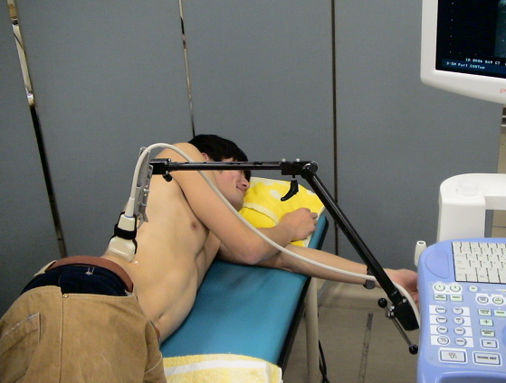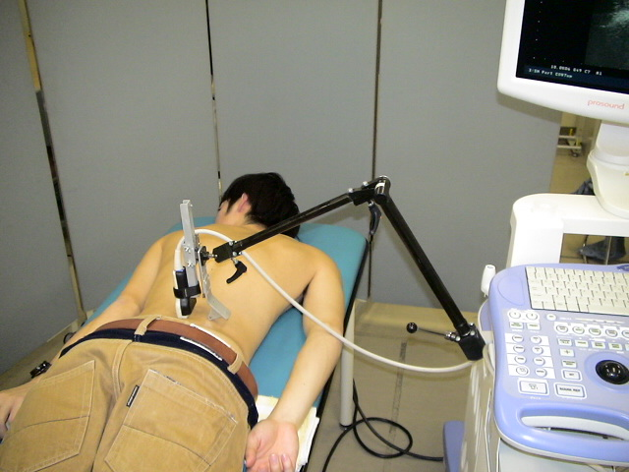
Figure 1 Measurements of ultrasound imaging for the lateral abdominal muscles (A) and the lumbar multifidus muscle (B)
A
B

Table 1 Intra-examiner reliability
 |  | ICC (1,3) | SEM (mm) | MDC (mm)
TrA | 0.1 N | 0.99 | 0.1 | 0.4
 | 2.0 N | 0.99 | 0.1 | 0.4
IO | 0.1 N | 0.99 | 0.4 | 1.2
 | 2.0 N | 0.99 | 0.4 | 1.2
EO | 0.1 N | 0.98 | 0.4 | 1.0
 | 2.0 N | 0.99 | 0.3 | 0.7
LM | 0.1 N | 0.99 | 0.4 | 1.1
 | 2.0 N | 0.99 | 0.4 | 1.1
ICC: intraclass correlation coefficients; SEM: standard error of measurement; MDC: minimal detectable change; TrA: transverse abdominis; IO: internal oblique; EO: external oblique; LM: lumbar multifidus.

Legends
<Total amount of figures and tables in the manuscript: 1/2 page >
<Size: 1/4 page >
Figure 1 Measurements of ultrasound imaging for the lateral abdominal muscles (A) and the lumbar multifidus muscle (B)

<Size: 1/4 page >
Table 1 Intra-examiner reliability
ICC: intraclass correlation coefficients; SEM: standard error of measurement; MDC: minimal detectable change; TrA: transverse abdominis; IO: internal oblique; EO: external oblique; LM: lumbar multifidus.

Note: "Total amount of figures and tables" in the second line is the total amount of figures and tables that the authors assumed each figure and table would occupy at the time of printing (publication of the paper). In the above example, Figure 1 and Table 1 are both 1/4 page, so 1/4 + 1/4 = 1/2 (0.5 page).

